# 

Group Assignment on Forecasting: Principles and Practice

Time Series Analysis

Submitted by:

Group-2:

20231057, 20231060, 20231061, 20231062, 20231063, 20231064, 20231067, 20231068

Submitted to:

###### Nasrin Khatun

Assistant Professor  
Department of Statistics and Data Science

Date of Submission:

15th May, 2024

# Solution of the Exercises:

1. Use the help menu to explore what the series gold, woolyrnq and gas represent. These are available in the forecast package.

> str(gold)

Time-Series [1:1108] from 1 to 1108: 306 300 303 297 304 ...

> str(woolyrnq)

Time-Series [1:119] from 1965 to 1994: 6172 6709 6633 6660 6786 ...

> str(gas)

Time-Series [1:476] from 1956 to 1996: 1709 1646 1794 1878 2173 ...

**1(a)**

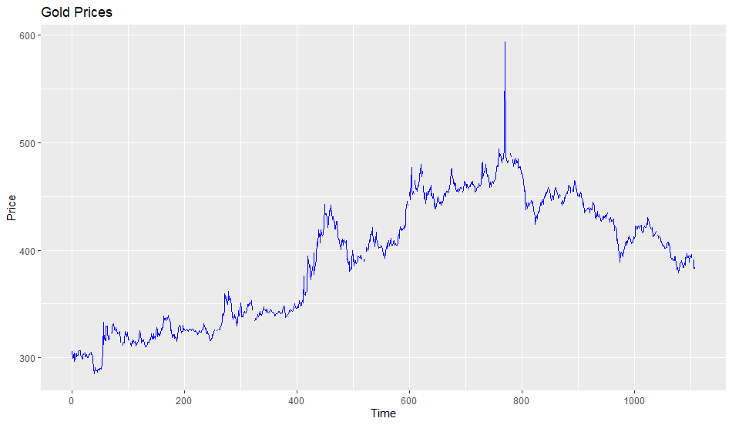

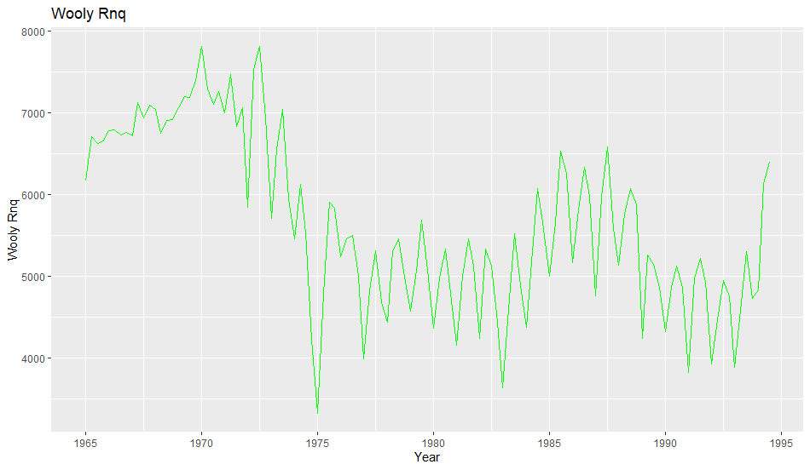

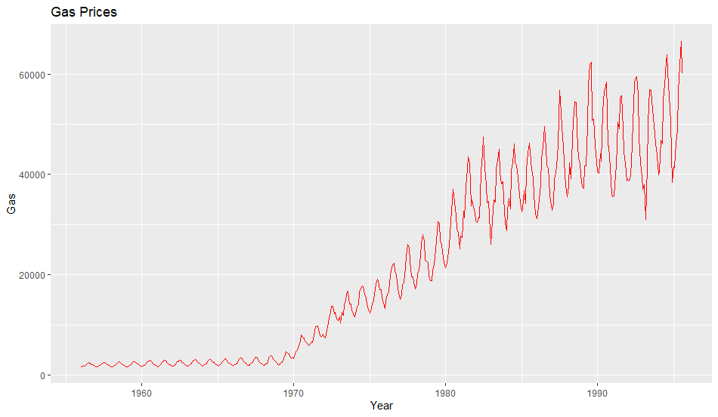

**1(b)**

> # Frequency of each series

> frequency(gold)

[1] 1

> frequency(woolyrnq)

[1] 4

> frequency(gas)

[1] 12

**1(c)**

## [1] "When gold got maximum value?"

## [1] 770

## [1] "What was the gold's maximum value?"

## [1] 593.7

## [1] "When woolyrnq got maximum value?"

## [1] 21

## [1] "What was the woolyrnq's maximum value?"

## [1] 7819

2. Download the file tute1.csv from OTexts.org/fpp2/extrafiles/tute1.csv, open it in Excel (or some other spreadsheet application), and review its contents. You should find four columns of information. Columns B through D each contain a quarterly series, labelled Sales, AdBudget and GDP. Sales contains the quarterly sales for a small company over the period 1981-2005. AdBudget is the advertising budget and GDP is the gross domestic product. All series have been adjusted for inflation.

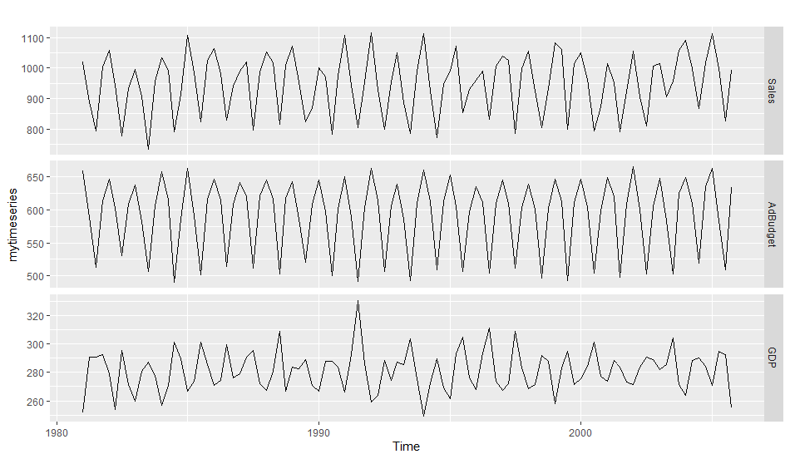

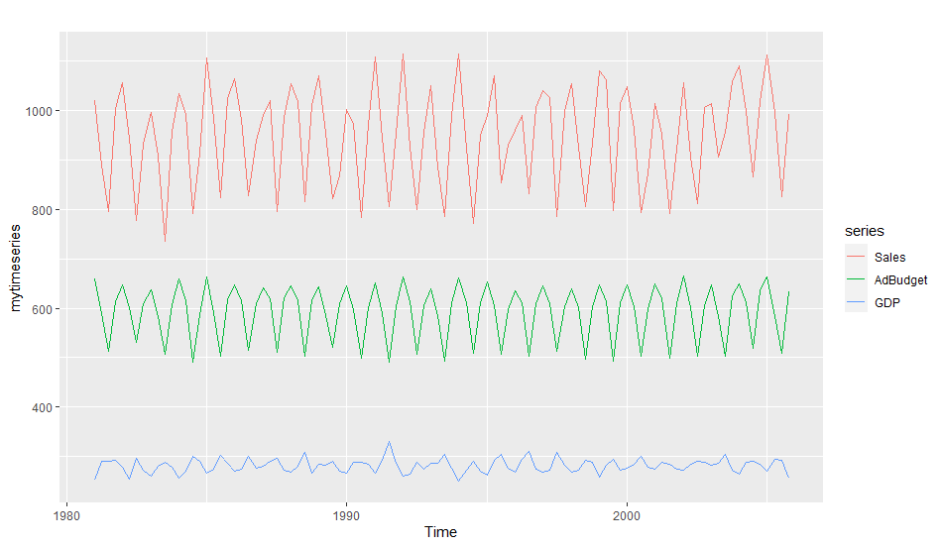

3. Download some monthly Australian retail data from OTexts.org/fpp2/extrafiles/retail.xlsx. These represent retail sales in various categories for different Australian states, and are stored in a MS-Excel file.

Read the retail.xlsx dataset

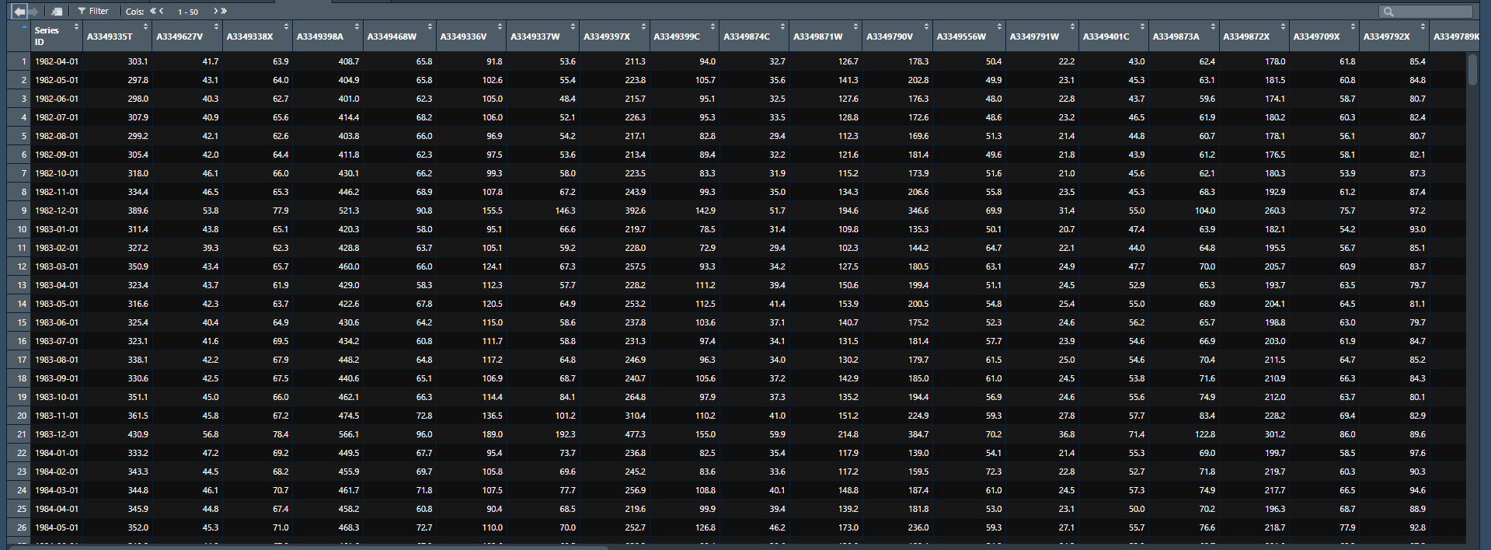

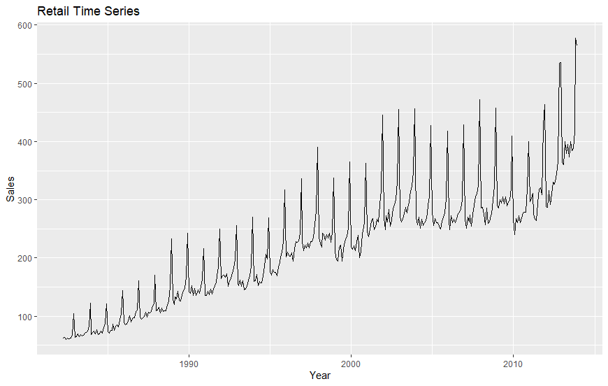

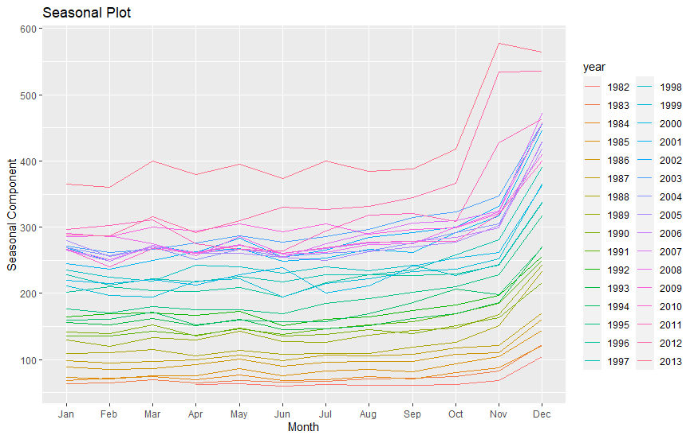

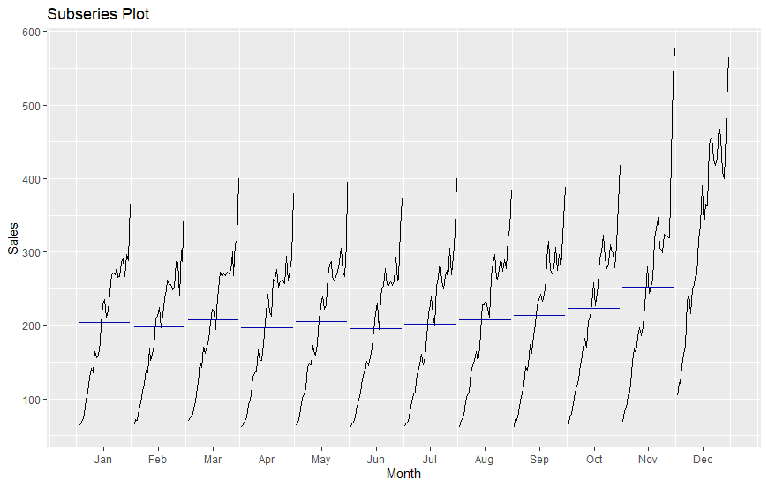

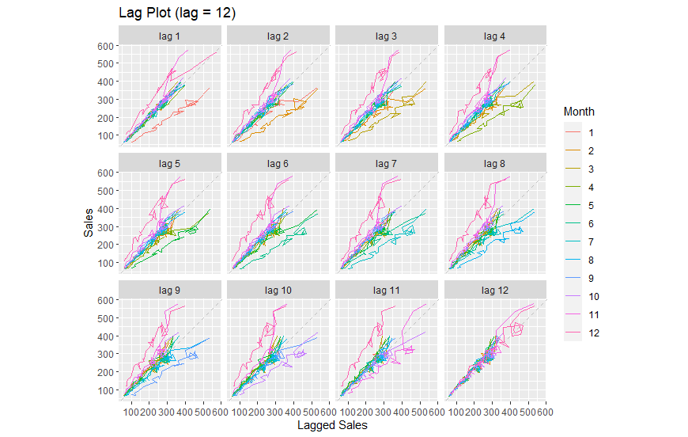

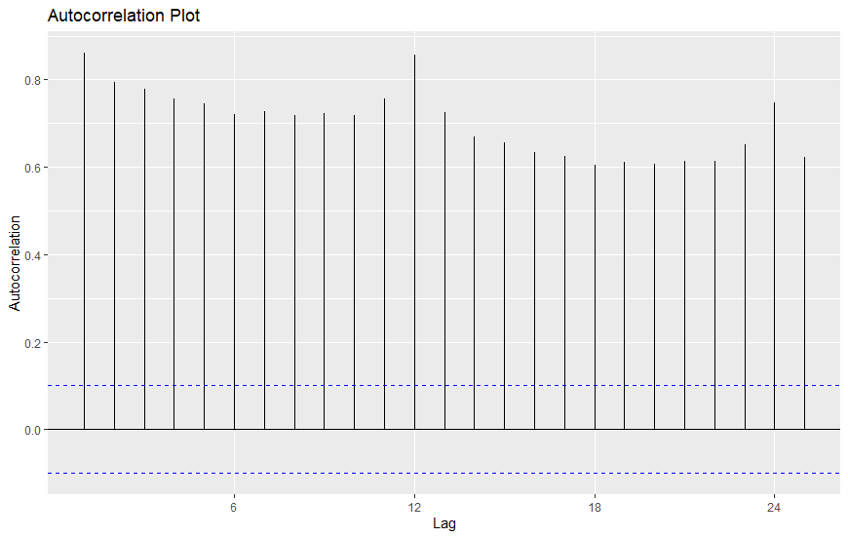

We can see seasonality and trend of the data.

4. Create time plots of the following times series: bicoal, chicken, dole, usdeaths, lynx, goog, writing, fancy, a10, h02.

Use help () to find out about the data in each series.

For the goog plot, modify the axis labels and title.

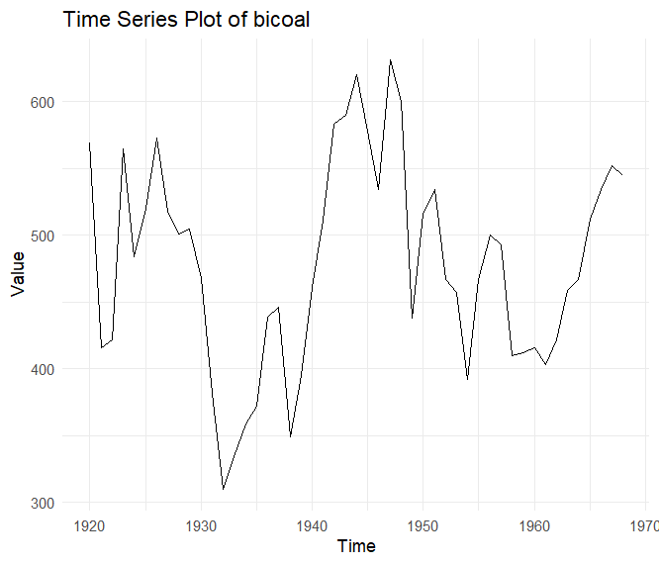

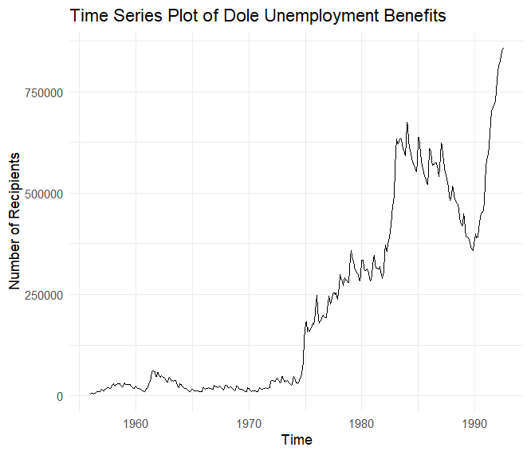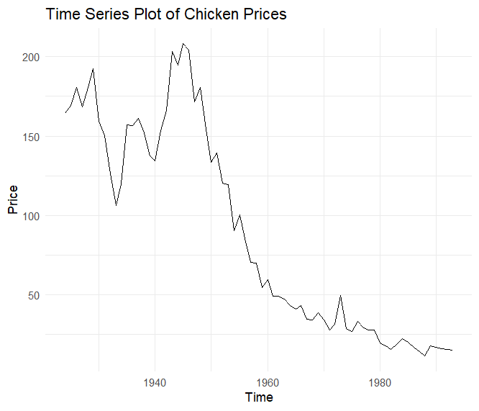

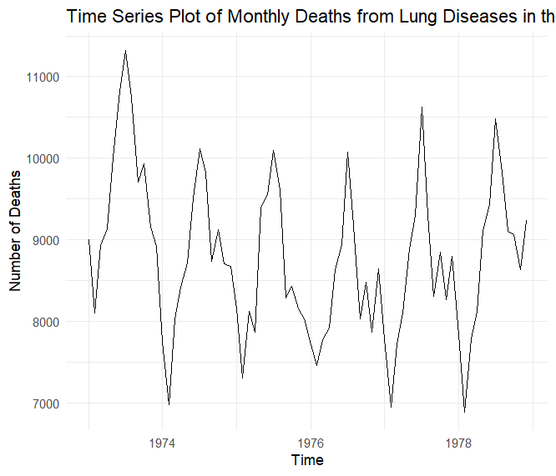

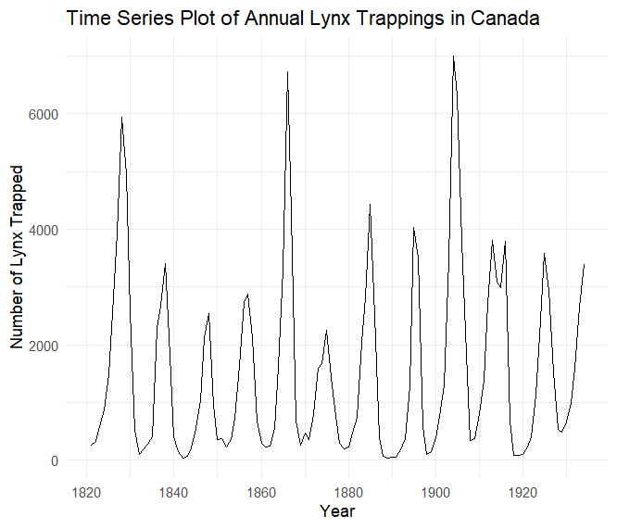

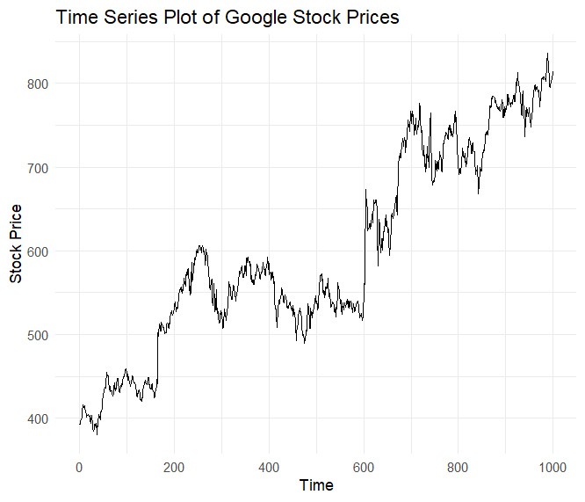

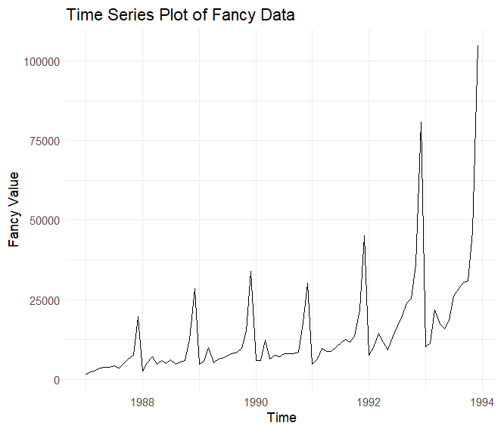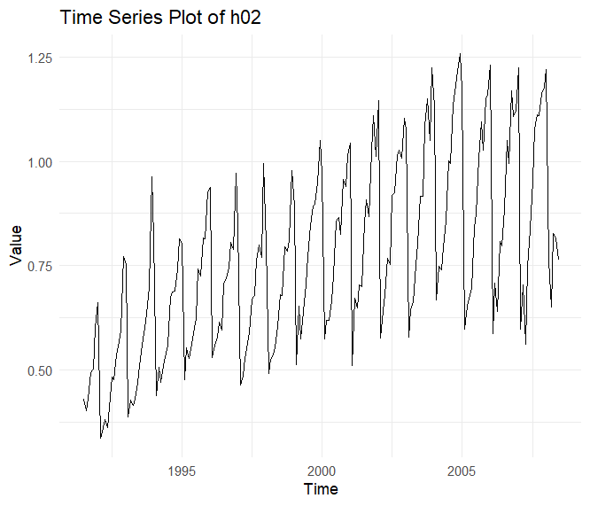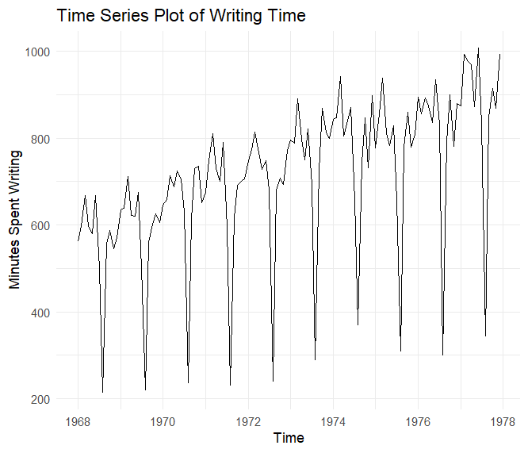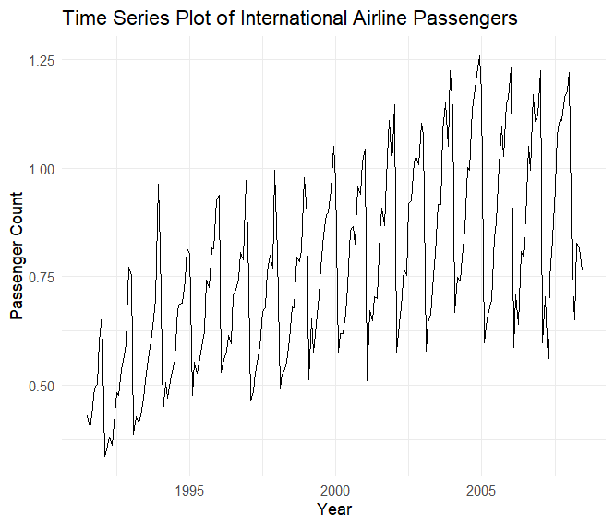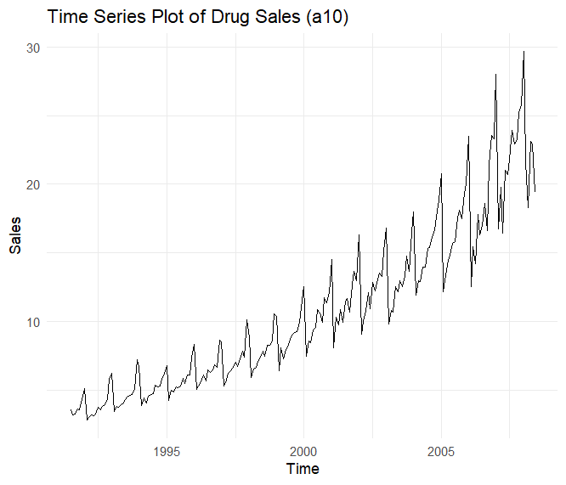

bicoal {fma} R Documentation

Annual bituminous coal production

Description

Annual bituminous coal production in the USA: 1920–1968.

Usage

bicoal

Format

Time series data

Source

Makridakis, Wheelwright and Hyndman (1998) Forecasting: methods and applications, John Wiley & Sons: New York. Exercise 7.7.

Examples

Run examples

tsdisplay(bicoal)

[Package fma version 2.5 Index]

|  |  |
| --- | --- |
| chicken {fma} | R Documentation |

## Price of chicken

### Description

Price of chicken in US (constant dollars): 1924–1993.

### Usage

chicken

### Format

Time series data

### Source

Makridakis, Wheelwright and Hyndman (1998) Forecasting: methods and applications, John Wiley & Sons: New York. Chapter 9.

### Examples

[Run examples](http://127.0.0.1:10183/help/library/fma/Example/chicken)

plot(chicken)

|  |  |
| --- | --- |
| dole {fma} | R Documentation |

## Unemployment benefits in Australia

### Description

Monthly total of people on unemployment benefits in Australia (Jan 1965 – Jul 1992).

### Usage

dole

### Format

Time series data

### Source

Makridakis, Wheelwright and Hyndman (1998) Forecasting: methods and applications, John Wiley & Sons: New York. Exercise 2.3.

### Examples

[Run examples](http://127.0.0.1:10183/help/library/fma/Example/dole)

plot(dole)

tsdisplay(dole)

[Package fma version 2.5 [Index](http://127.0.0.1:10183/help/library/fma/html/00Index.html)]

usdeaths {fma} R Documentation

Accidental deaths in USA

Description

Monthly accidental deaths in USA.

Usage

usdeaths

Format

Time series data

Source

Makridakis, Wheelwright and Hyndman (1998) Forecasting: methods and applications, John Wiley & Sons: New York. Exercises 2.3 and 2.4.

Examples

Run examples

plot(usdeaths)

seasonplot(usdeaths)

tsdisplay(usdeaths)

[Package fma version 2.5 Index]

Help on topic 'lynx' was found in the following packages:

Annual Canadian Lynx trappings 1821-1934

(in package datasets in library C:/Program Files/R/R-4.3.2/library)

Annual Canadian Lynx trappings 1821-1934

(in package fma in library C:/Users/ASUS/AppData/Local/R/win-library/4.3)

|  |  |
| --- | --- |
| goog {fpp2} | R Documentation |

## Daily closing stock prices of Google Inc

### Description

Closing stock prices of GOOG from the NASDAQ exchange, for 1000 consecutive trading days between 25 February 2013 and 13 February 2017. Adjusted for splits. goog200 contains the first 200 observations from goog.

### Format

Daily time series of class ts.

### Source

<https://finance.yahoo.com/quote/GOOG/history>

### Examples

[Run examples](http://127.0.0.1:10183/help/library/fpp2/Example/goog)

autoplot(goog)

[Package fpp2 version 2.5 [Index](http://127.0.0.1:10183/help/library/fpp2/html/00Index.html)]

writing {fma} R Documentation

Sales of printing and writing paper

Description

Industry sales for printing and writing paper (in thousands of French francs): Jan 1963 – Dec 1972.

Usage

writing

Format

Time series data

Source

Makridakis, Wheelwright and Hyndman (1998) Forecasting: methods and applications, John Wiley & Sons: New York. Chapter 7.

Examples

Run examples

tsdisplay(writing)

seasonplot(writing)

[Package fma version 2.5 Index]

fancy {fma} R Documentation

Sales for a souvenir shop

Description

Monthly sales for a souvenir shop on the wharf at a beach resort town in Queensland, Australia.

Usage

fancy

Format

Time series data

Source

Makridakis, Wheelwright and Hyndman (1998) Forecasting: methods and applications, John Wiley & Sons: New York. Exercise 5.8.

Examples

Run examples

plot(fancy)

seasonplot(fancy)

[Package fma version 2.5 Index]

a10 {fpp2} R Documentation

Monthly anti-diabetic drug subsidy in Australia from 1991 to 2008.

Description

Monthly government expenditure (millions of dollars) as part of the Pharmaceutical Benefit Scheme for products falling under ATC code A10 as recorded by the Australian Health Insurance Commission. July 1991 - June 2008.

Format

Monthly time series of class ts.

Source

Medicare Australia

Examples

Run examples

autoplot(a10)

ggseasonplot(a10)

[Package fpp2 version 2.5 Index]

|  |  |
| --- | --- |
| h02 {fpp2} | R Documentation |

## Monthly corticosteroid drug subsidy in Australia from 1991 to 2008.

### Description

Monthly government expenditure (millions of dollars) as part of the Pharmaceutical Benefit Scheme for products falling under ATC code H02 as recorded by the Australian Health Insurance Commission. July 1991 - June 2008.

### Format

Monthly time series of class ts.

### Source

Medicare Australia

### Examples

[Run examples](http://127.0.0.1:10183/help/library/fpp2/Example/h02)

autoplot(h02)

ggseasonplot(h02)

[Package fpp2 version 2.5 [Index](http://127.0.0.1:10183/help/library/fpp2/html/00Index.html)]

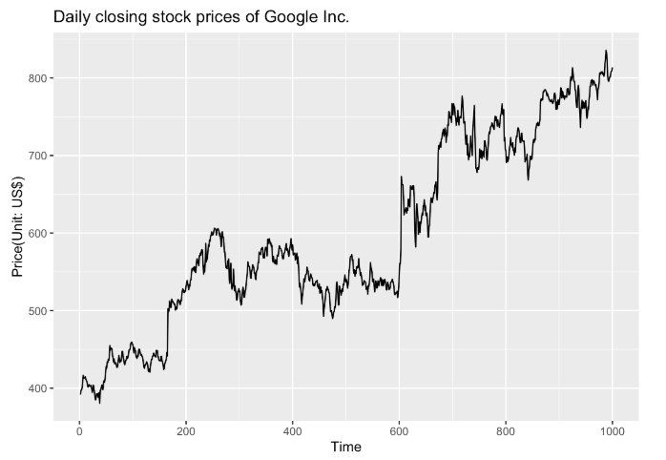

5. Use the ggseasonplot and ggsubseriesplot functions to explore the seasonal patterns in the following time series: writing, fancy, a10, h02.

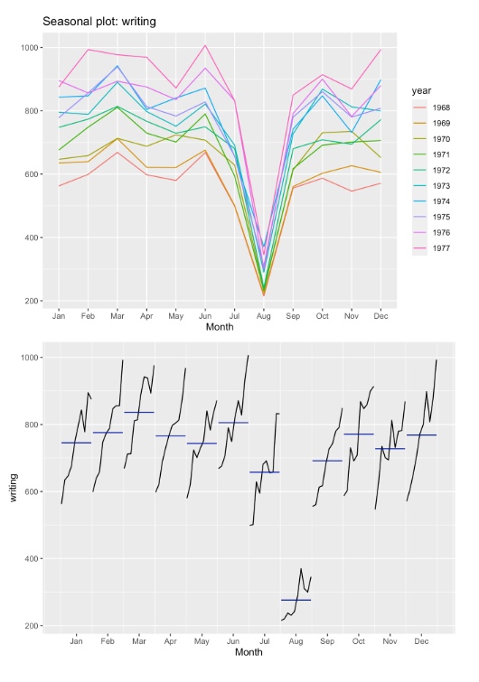

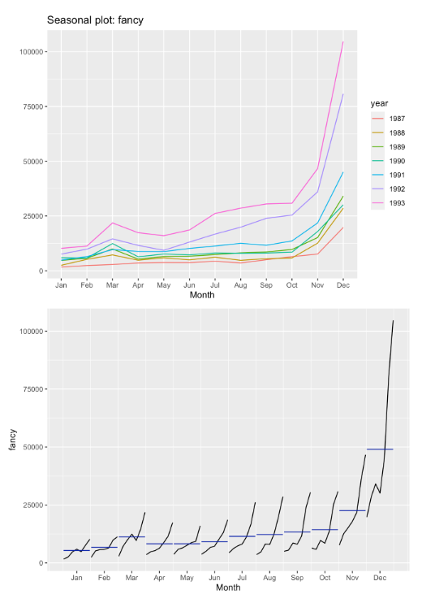

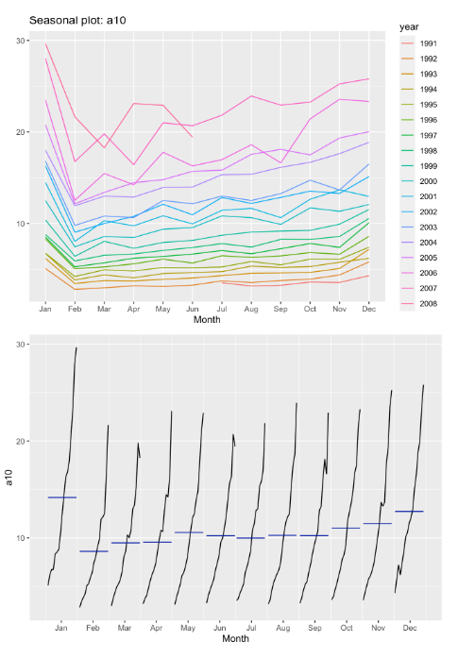

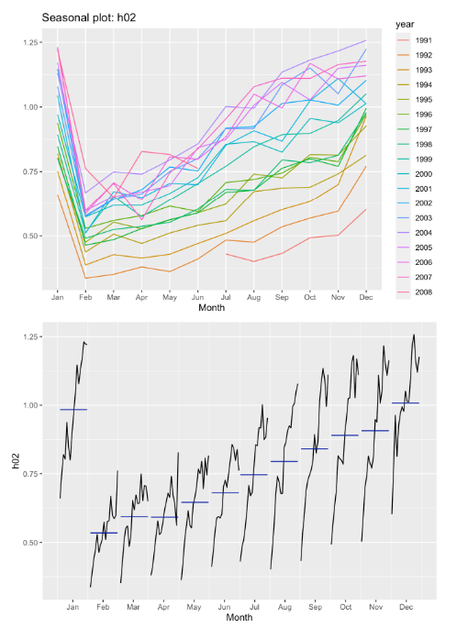

6. Use the the following graphics functions: autoplot, ggseasonplot, ggsubseriesplot, gglagplot, ggAcf and explore features from the following time series: hsales, usdeaths, bricksq, sunspotarea, gasoline.

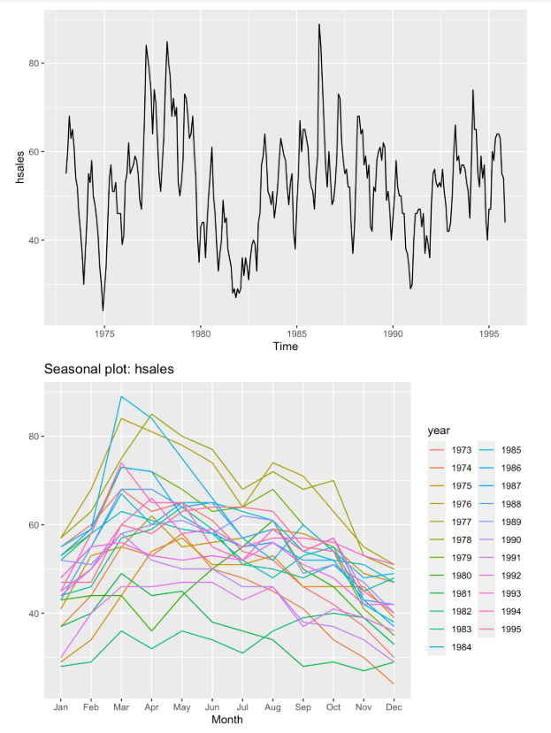

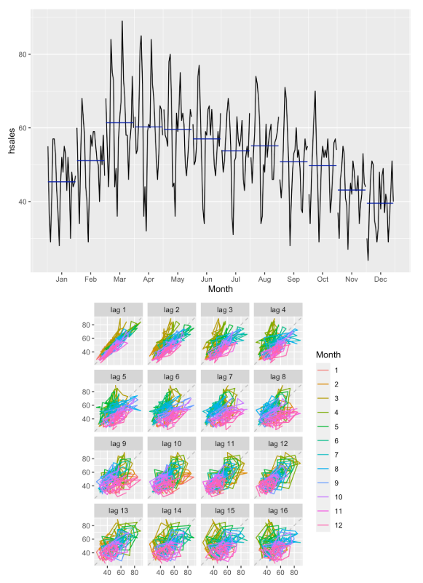

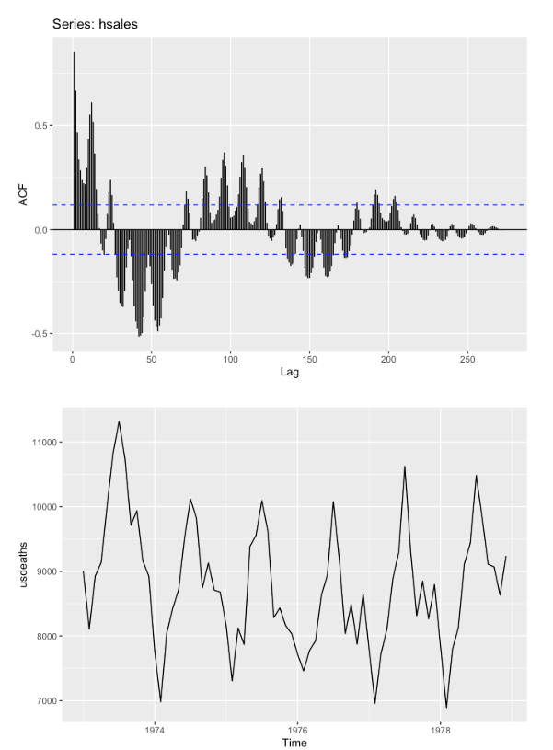

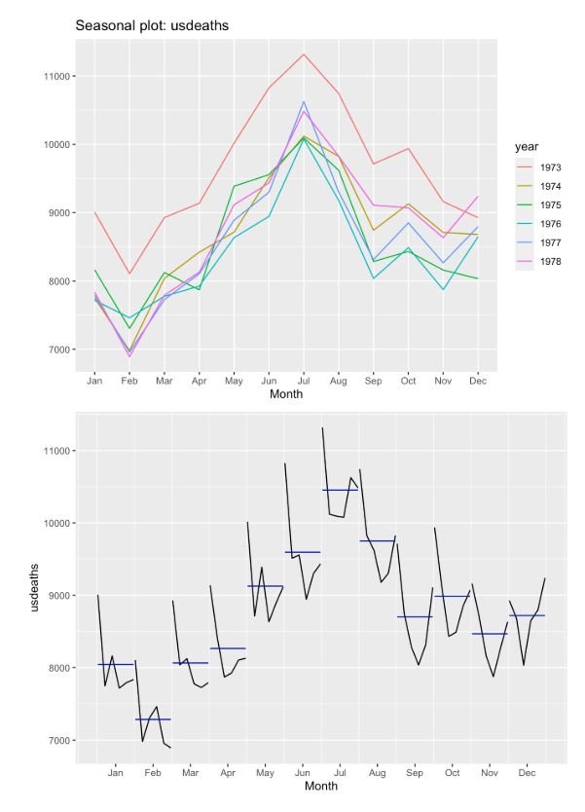

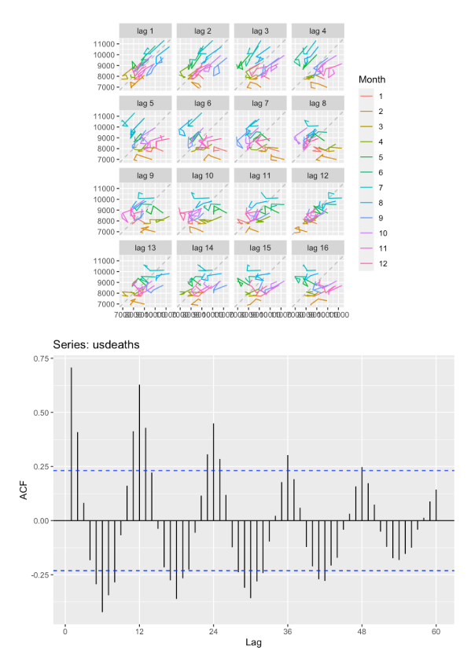

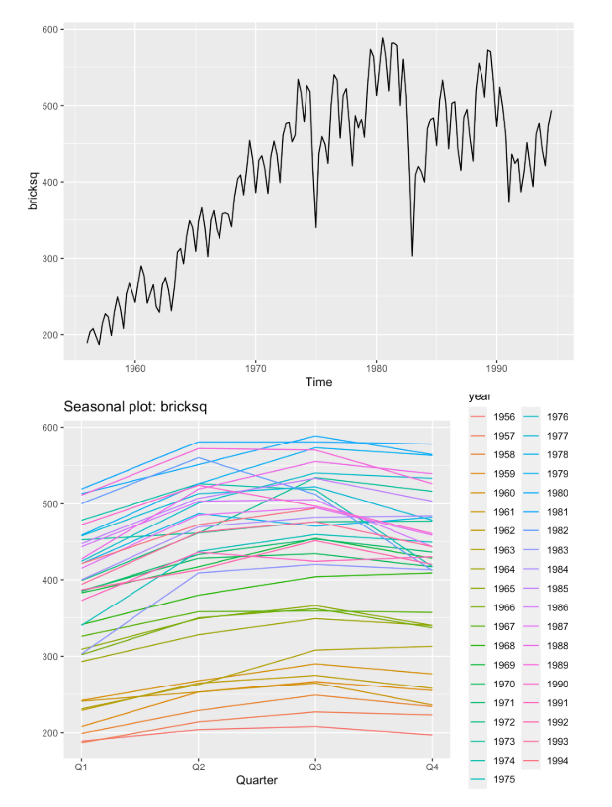

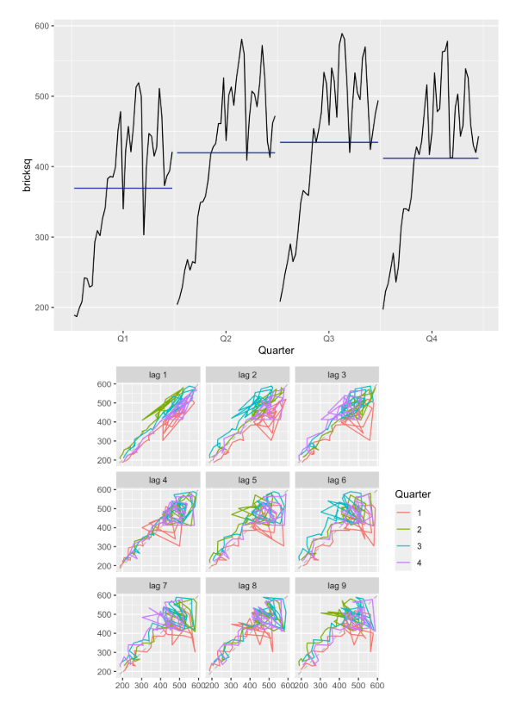

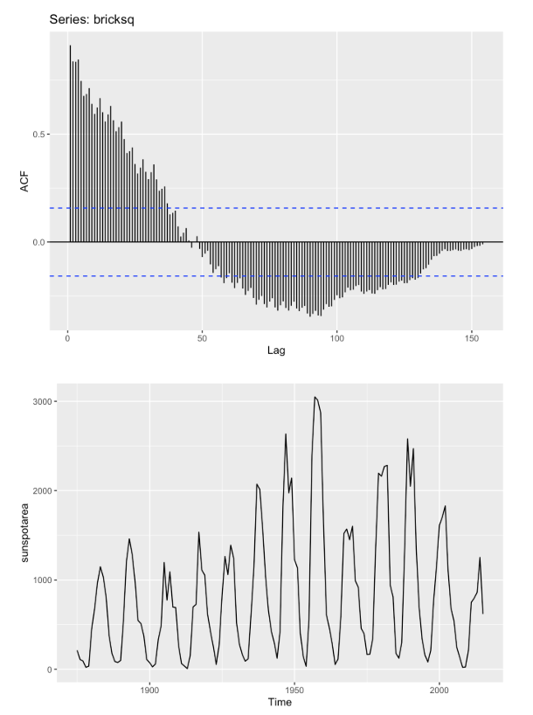

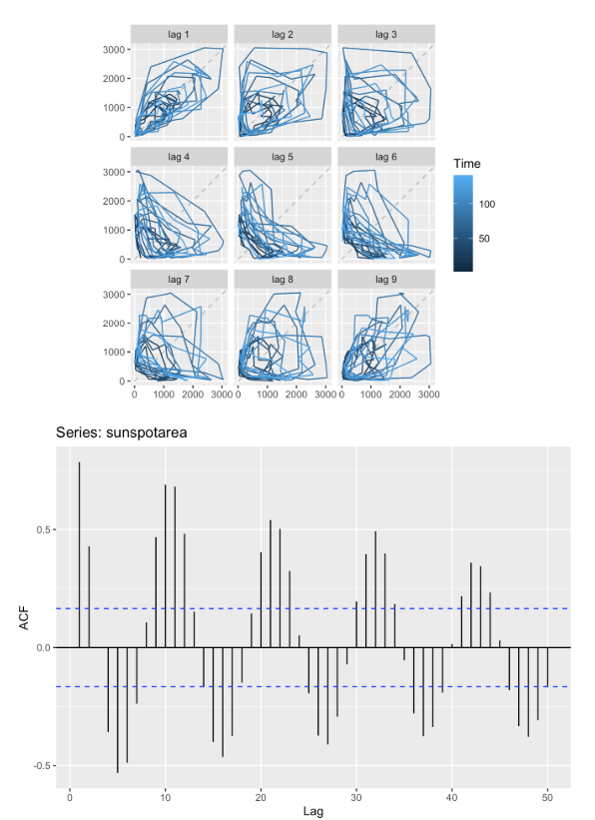

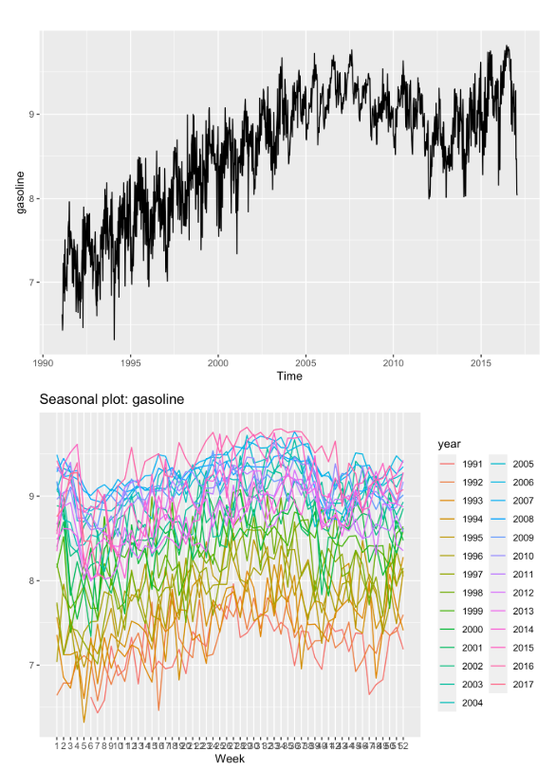

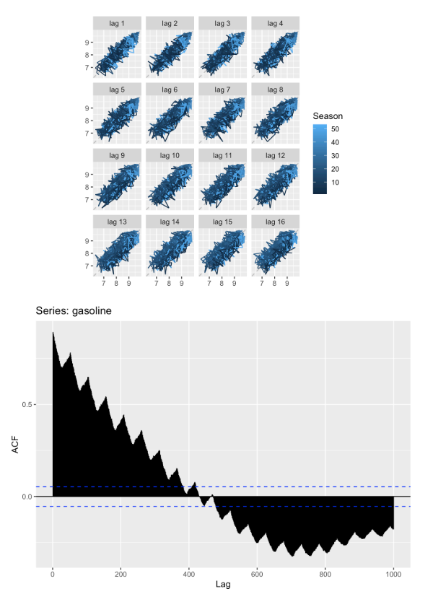

7. The arrivals data set comprises quarterly international arrivals (in thousands) to Australia from Japan, New Zealand, UK and the US.

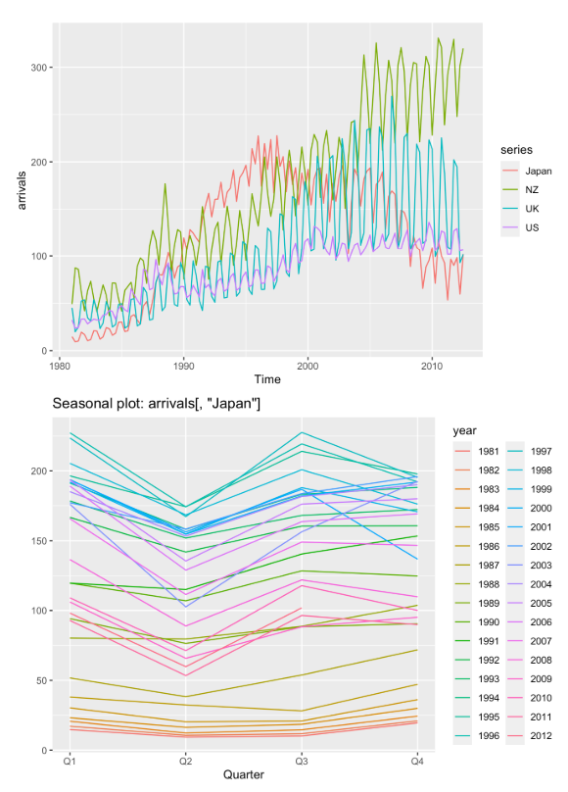

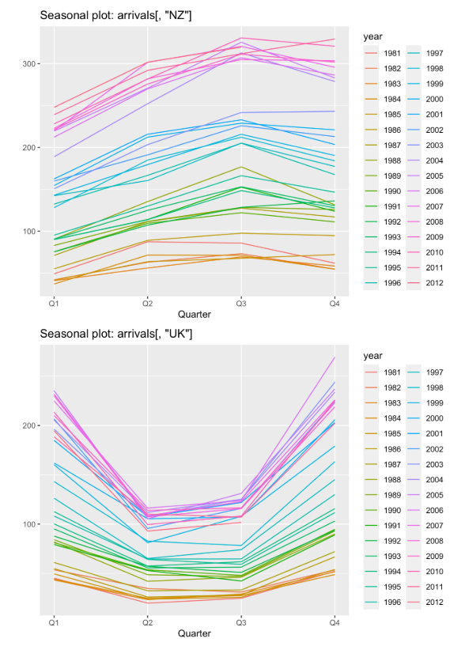

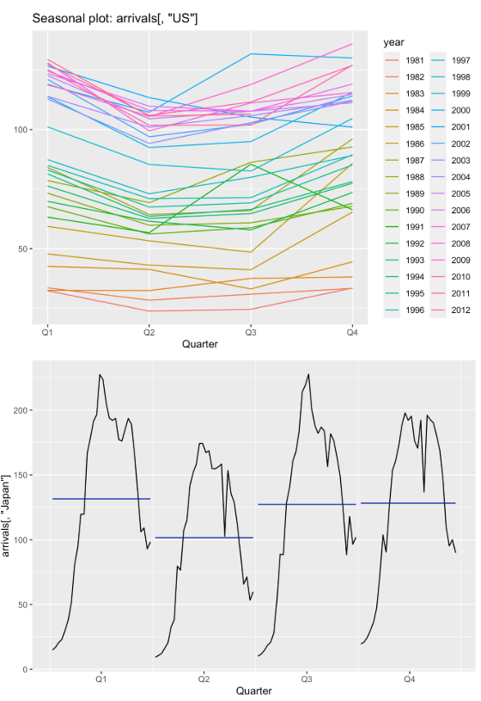

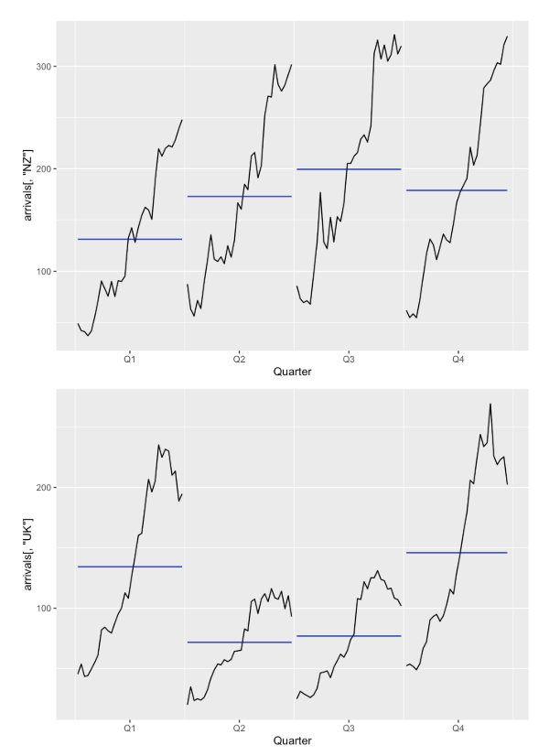

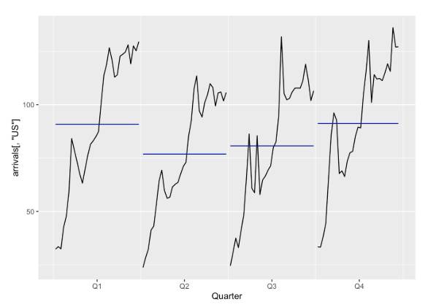

8. The following time plots as well as ACF plots correspond to four different time series. Your task is to match each time plot in the first row with one of the ACF plots in the second row.



To align the time plots with their corresponding Autocorrelation Function (ACF) plots, it's essential to understand the typical patterns exhibited by different types of time series data. Here's a general approach to assist you in making these matches:

1. Daily Temperature of Cow:

- Time Plot: Daily temperature data usually displays a smooth pattern with minor fluctuations around a central mean due to daily variations.

- ACF Plot: You would observe significant correlations at small lags (e.g., 1-2 days) owing to the high autocorrelation in daily temperatures.

2. Monthly Accidental Deaths:

- Time Plot: This series may exhibit seasonality or irregular patterns influenced by external factors affecting accidents.

- ACF Plot: The correlations might be weaker, but there could be noticeable seasonal effects resulting in periodic spikes.

3. Monthly Air Passengers:

- Time Plot: Typically, this data shows a pronounced seasonal pattern along with a clear upward trend.

- ACF Plot: You'll notice a strong seasonal component with prominent correlations at lags corresponding to the seasonal period (e.g., 12 months for annual seasonality).

4. Annual Mink Trappings:

- Time Plot: Annual trappings data might reveal long-term trends or cycles, but the sparse data points (one per year) limit insights.

- ACF Plot: Significant correlations at longer lags could indicate the presence of long-term cycles.

To facilitate matching, follow these steps:

- Identify Seasonal Patterns: Look for time plots with evident seasonal cycles, corresponding to ACF plots displaying peaks at seasonal intervals.

- Trend and Cyclical Patterns: Time plots featuring clear trends (upward or downward) and possibly cycles will exhibit slowly declining ACF plots.

- Daily Variations: Time plots with consistent, minor variations will reflect high ACF values at small lags, decreasing rapidly thereafter.

- Sparse Annual Data: Identify time plots with few data points (annual), accompanied by ACF plots showing significant correlations at longer lags.

By applying these principles, we can correlate each time plot with its corresponding ACF plot. However, without visual aids, this explanation serves as a conceptual guide rather than providing definitive matches. Actual plots would enable you to employ this framework effectively for pattern identification in each time series.

9. The pigs data shows the monthly total number of pigs slaughtered in Victoria, Australia, from Jan 1980 to Aug 1995. Use mypigs <- window (pigs, start=1990) to select the data starting from 1990. Use autoplot and ggAcf for mypigs series and compare these to white noise plots from Figures 2.17 and 2.18.

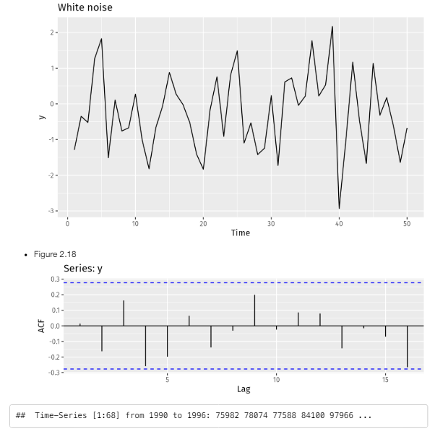

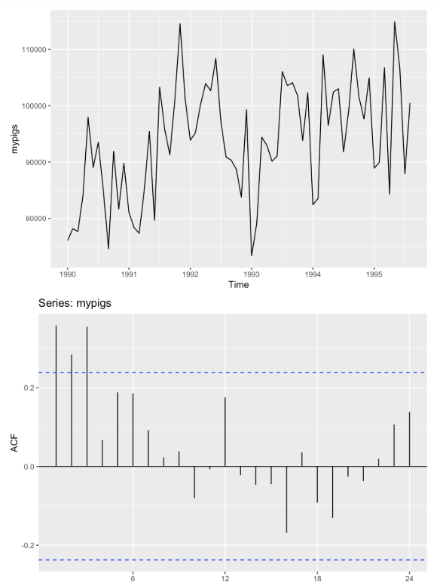

We can find that 3 autocorrelation values were outside of bounds. Therefore mypigs isn't probably white noise.

10. dj contains 292 consecutive trading days of the Dow Jones Index. Use ddj <- diff(dj) to compute the daily changes in the index. Plot ddj and its ACF. Do the changes in the Dow Jones Index look like white noise?

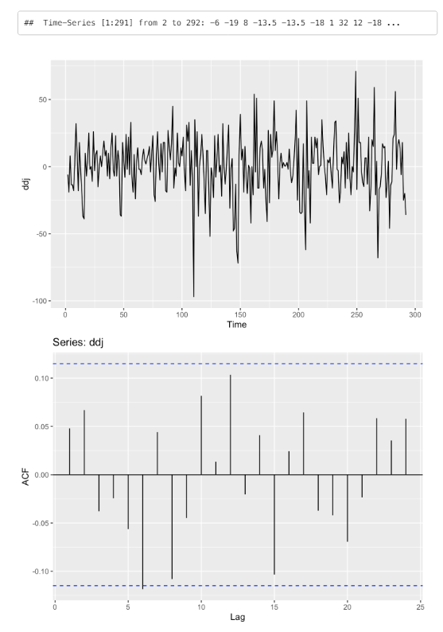

We can find that substantially less than 5% of autocorrelation values were outside of bounds. Therefore, ddj can be white noise.